**Cab booking service and voucher sanction service**

**Description:**

This project involves the user who wants to travel over the cab, have to booking prior for their travel confirmation. And also the user might be travel into the private when the cab is not available. On that time they may send their bill details to the management for sanction process**.**

**Module Details**

1. Registering user details
2. Login module
3. Admin Module
4. User Booking for a cab
5. Booking Confirmation
6. Voucher module
7. Voucher Confirmation
8. Report Generation

**Use case diagram for Cab Request**

Dash Board

Dash Board

Dash Board

**Screen Shots:**

1. **Registration form**

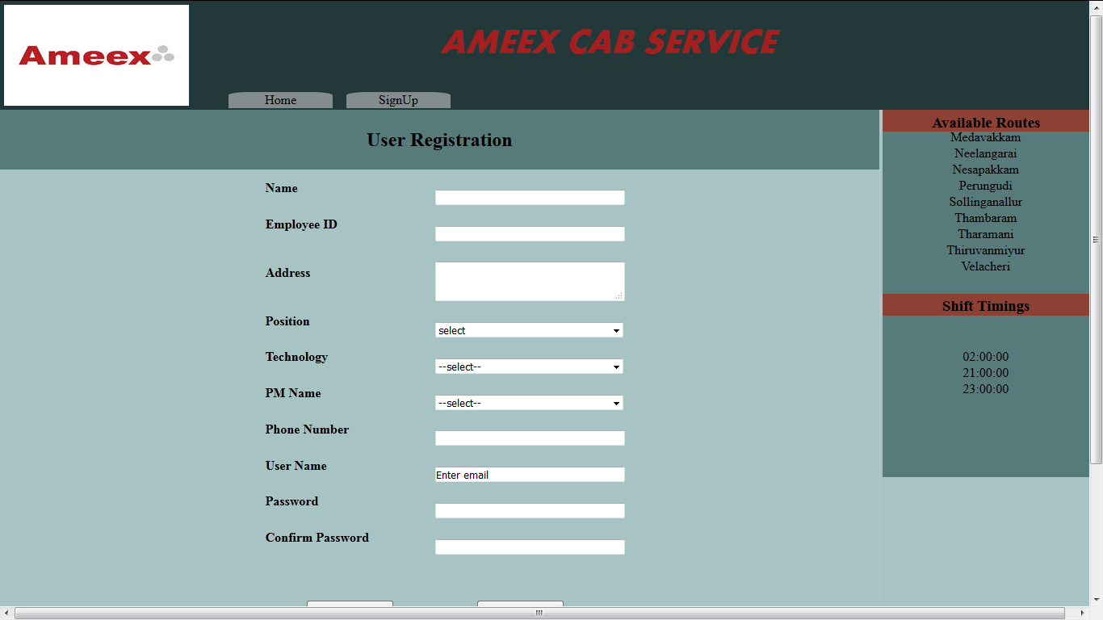

1. **Login Form**

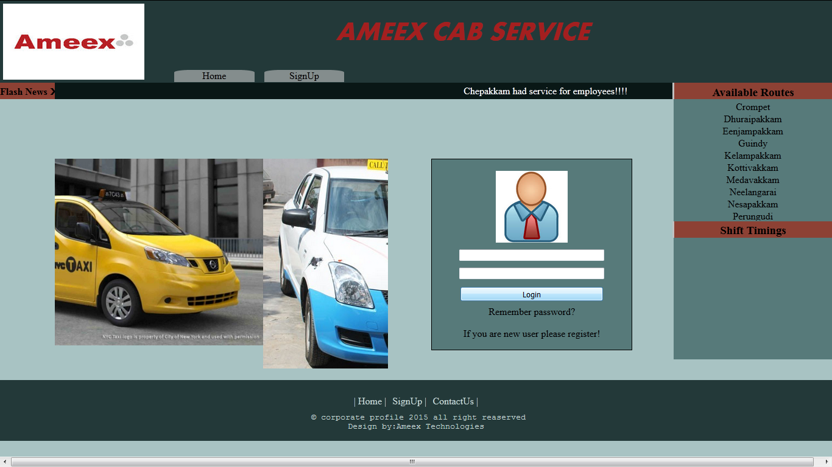

1. **Booking Request form**

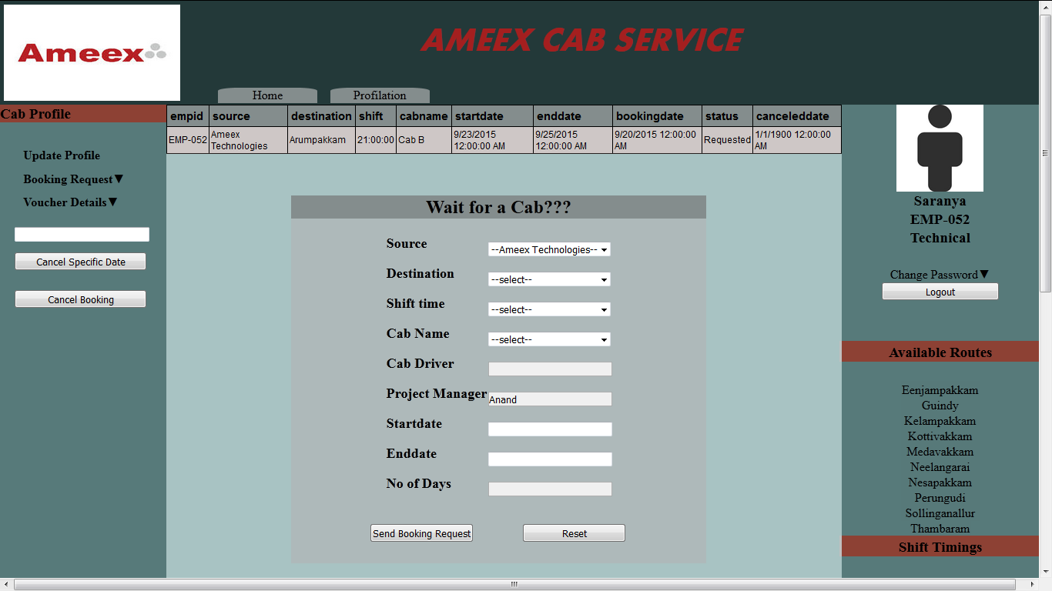

1. **Booking Confirmation form**

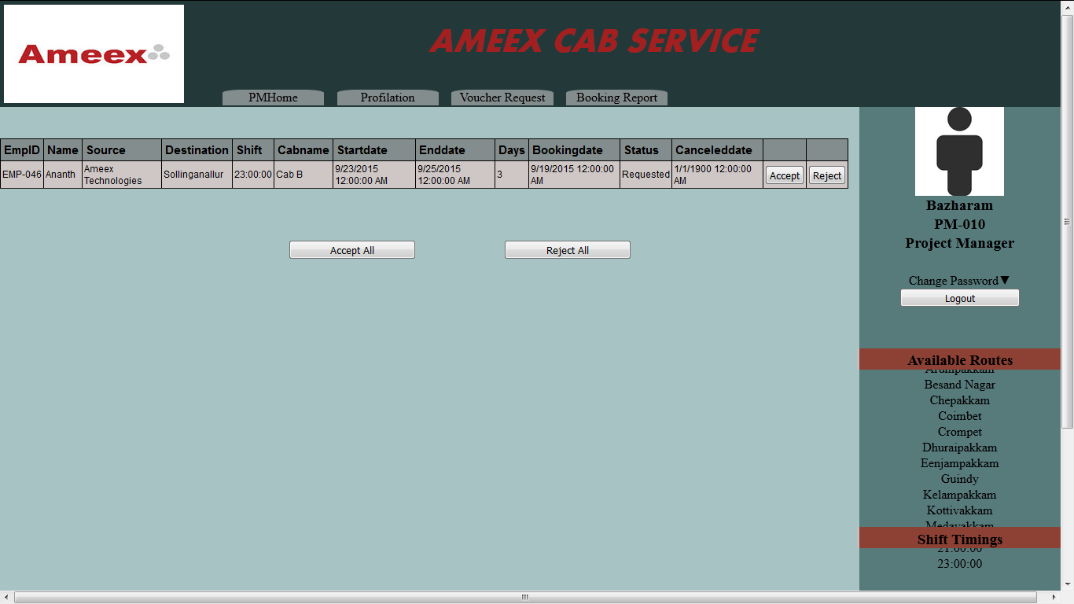

1. **Voucher Details**

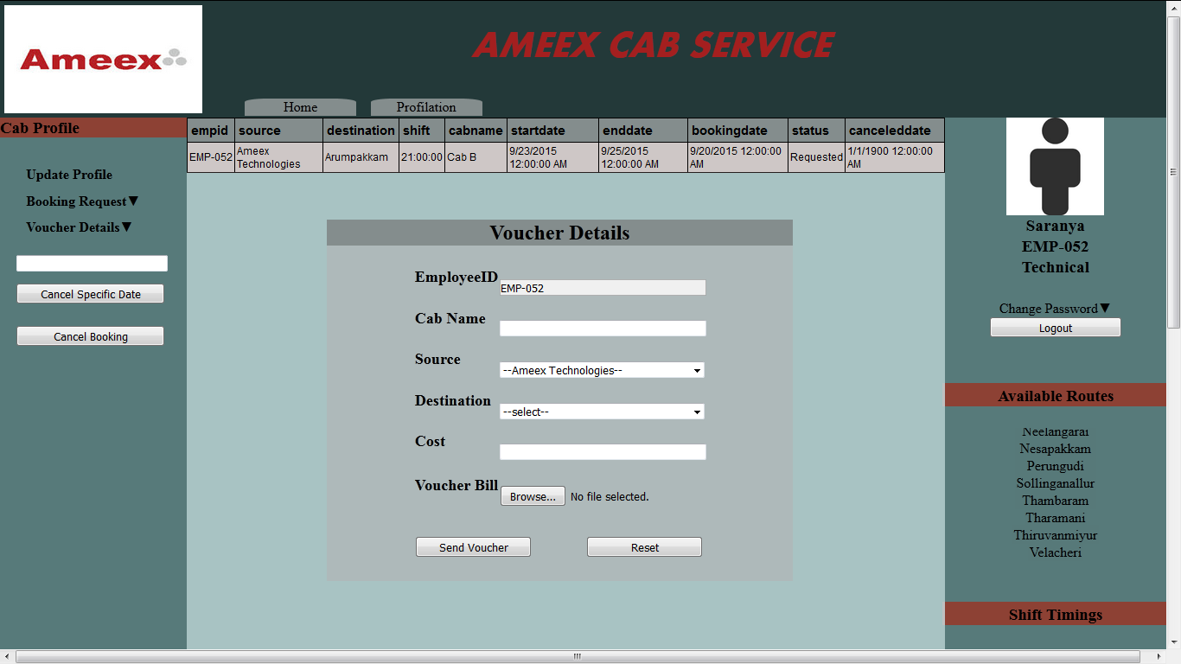

1. **Voucher Confirmation form**

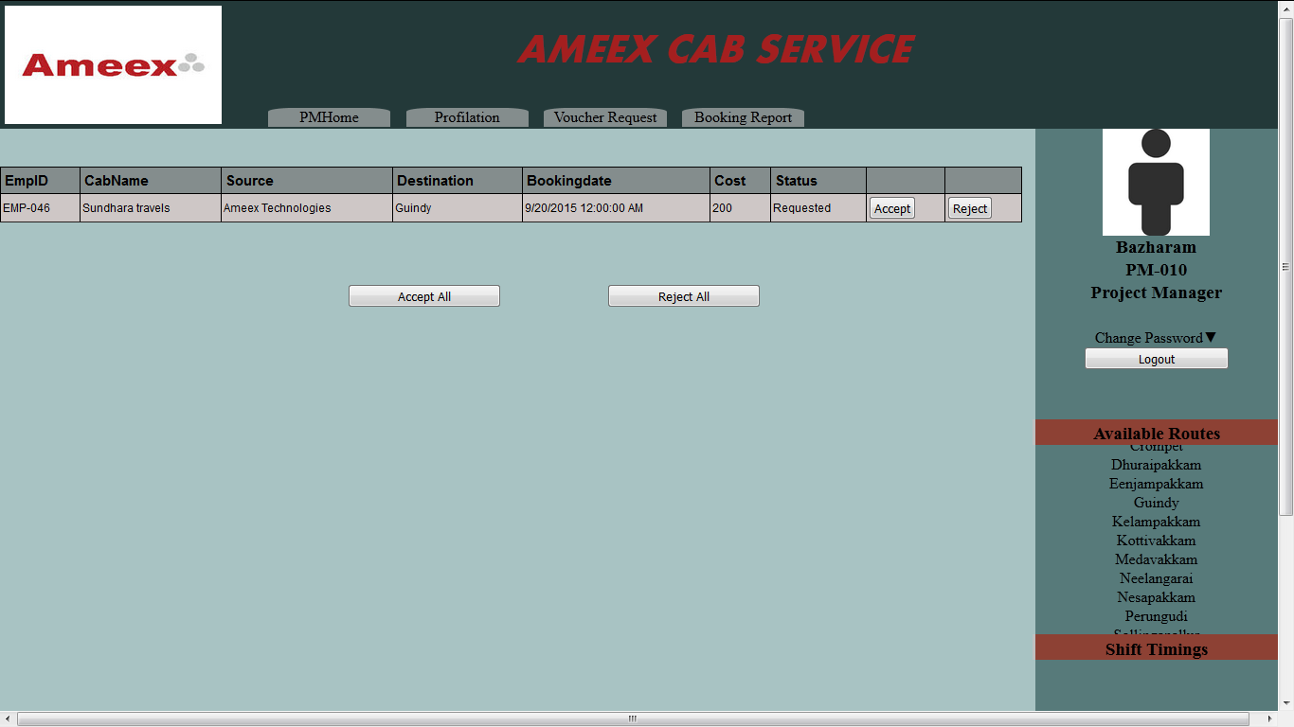

1. **Service Notification**

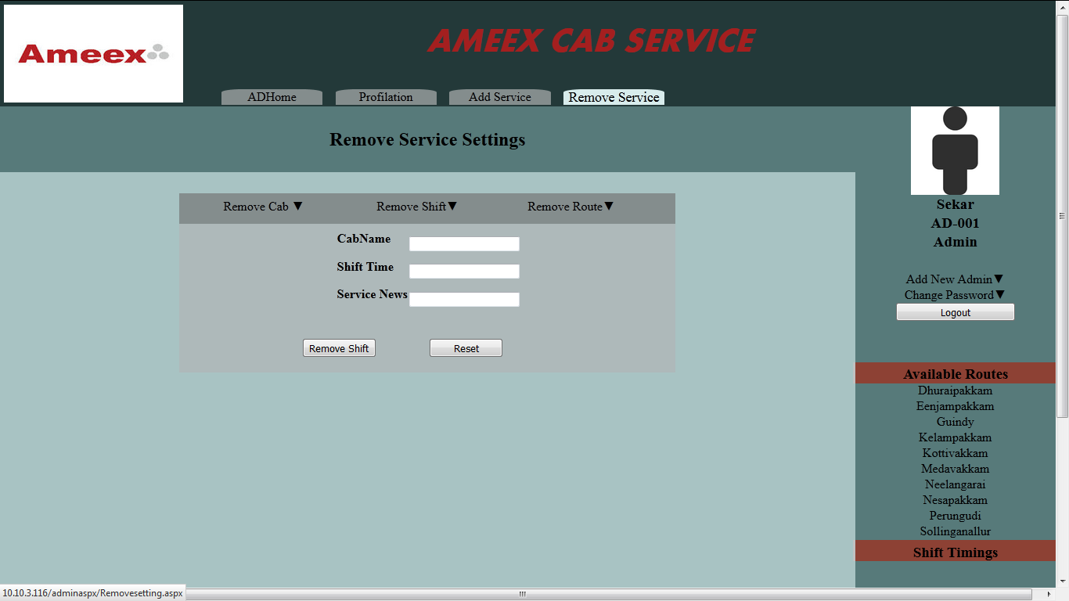

1. **Booking Report**

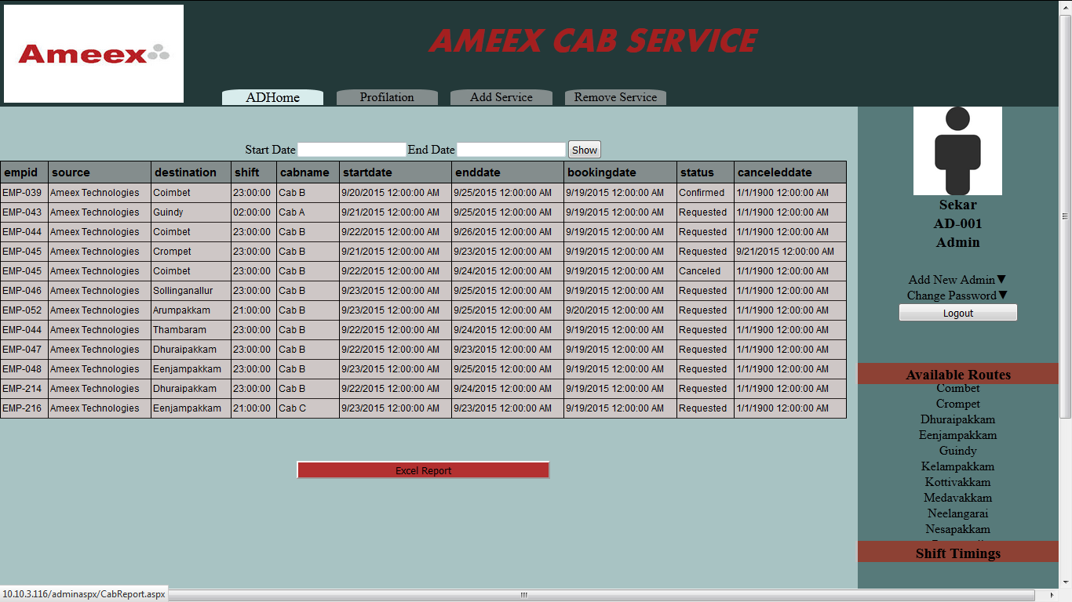

1. **Voucher Report**

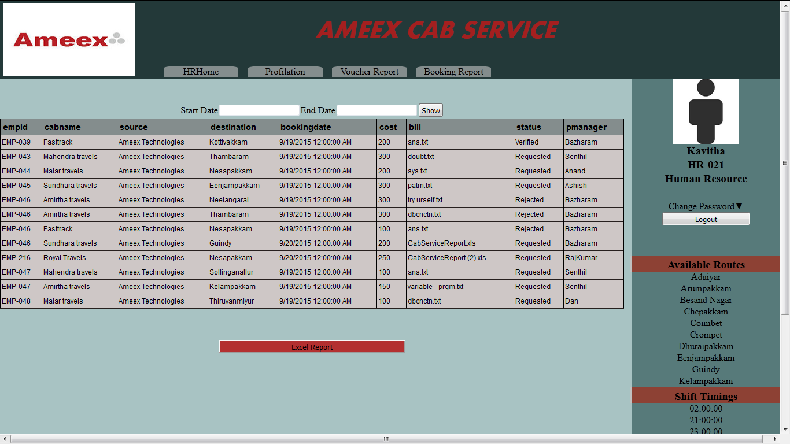

**Database Schema**

1. **Profile table:**

|  |  |  |  |
| --- | --- | --- | --- |
| **Column Name** | **Data type** | **key** | **Not null** |
| Emp_id | nvarchar(MAX) | Primary key | Not null |
| Name | nvarchar(MAX) |  | Not null |
| Address | nvarchar(MAX) |  | Not null |
| Position | nvarchar(MAX) |  | Not null |
| Technology | nvarchar(MAX) |  | Not null |
| Project _manager | nvarchar(MAX) |  | Not null |
| Username | nvarchar(MAX) |  | Not null |
| Password | nvarchar(MAX) |  | Not null |
| Account_type | nvarchar(20) |  | Not null |
| Phone | Nvarchar(20) |  | Not null |

1. **Booking details table:**

|  |  |  |  |
| --- | --- | --- | --- |
| **Column Name** | **Data type** | **key** | **Not null** |
| Emp_id | nvarchar(MAX) | Forgien key | Not null |
| Name | nvarchar(MAX) |  | Not null |
| Source | nvarchar(MAX) |  | Not null |
| Destination | nvarchar(MAX) |  | Not null |
| Shift_time | time(7) |  | Not null |
| Cab_name | nvarchar(MAX) |  | Not null |
| start_date | date |  | Not null |
| End_date | date |  | Not null |
| No_of_days | int |  | Not null |
| Booking_date | datetime |  | Not null |
| Status | nvarchar(20) |  | Not null |
| Cancel_date | date |  | Not null |
| Project_Manager | Nvarchar(MAX) |  | Not null |

1. **Voucher table:**

|  |  |  |  |
| --- | --- | --- | --- |
| **Column Name** | **Data type** | **key** | **Not null** |
| Emp_id | nvarchar(MAX) | Primary key | Not null |
| Cabname | nvarchar(MAX) |  | Not null |
| Cab_name | nvarchar(MAX) |  | Not null |
| Source | nvarchar(MAX) |  | Not null |
| Destination | nvarchar(MAX) |  | Not null |
| Booking_date | date |  | Not null |
| Cost | float |  | Not null |
| Bill | nvarchar(MAX) |  | Not null |
| Status | nvarchar(20) |  | Not null |
| Project_Manager | Nvarchar(MAX) |  | Not null |

1. **Setting table:**

|  |  |  |
| --- | --- | --- |
| **Column Name** | **Data type** | **Not null** |
| cabname | nvarchar(50) | Not null |
| driver | nvarchar(50) | Not null |
| shift | time(7) | Not null |
| route | nvarchar(50) | Not null |
| news | nvarchar(MAX) | Not null |
| Capacity | int | Not null |

**Module Splitup:**

|  |  |  |  |  |  |
| --- | --- | --- | --- | --- | --- |
| Date | Name | Module | Duration | Status |  |
| 8/9/2015 | M.Ananth | Master Page for User module | 8hours | Completed |  |
|  | G.Saranya | Home page Login Module | 8hours | Completed |  |
|  | V.Tamizhendhi | Registation Page for users | 8hours | Completed |  |
| 9/9/2015 | M.Ananth | Booking request and voucher page | 16hours | Completed |  |
|  | G.Saranya | Dashboard for User profile | 16hours | Completed |  |
|  | V.Tamizhendhi | Dashboard for Admin profile | 16hours | Completed |  |
| 11/9/2015 | M.Ananth | Admin home page | 16hours | Completed |  |
|  | G.Saranya | forget password page | 16hours | Completed |  |
|  | V.Tamizhendhi | Admin master page and Embedding perungudi surrounding Gmap for Bus routes | 16hours | Completed |  |
| 15/9/2015 | M.Ananth | Report page for Admin | 8hours | Completed |  |
|  | G.Saranya | Booking confirmation page | 8hours | Completed |  |
|  | V.Tamizhendhi | Update profile page | 8hours | Completed |  |
| 16/9/2015 | M.Ananth | Add service setting page | 8hours | Completed |  |
|  | G.Saranya | Remove Cab form | 8hours | Completed |  |
|  | V.Tamizhendhi | Voucher report page | 8hours | Completed |  |
| 17/9/2015 | M.Ananth | Page organization | 8hours | Completed |  |
|  | G.Saranya | voucher request confirmation page | 8hours | Completed |  |
|  | V.Tamizhendhi | Remove shift and route form | 8hours | Completed |  |
|  |  |  |  |  |  |
|  |  |  |  |  |  |
|  |  |  |  |  |  |